*\*\*STATE DIAGRAMS ABOUT 9-12 REQUIREMENTS****\*\****

***Object 1: Transaction – State Diagram***

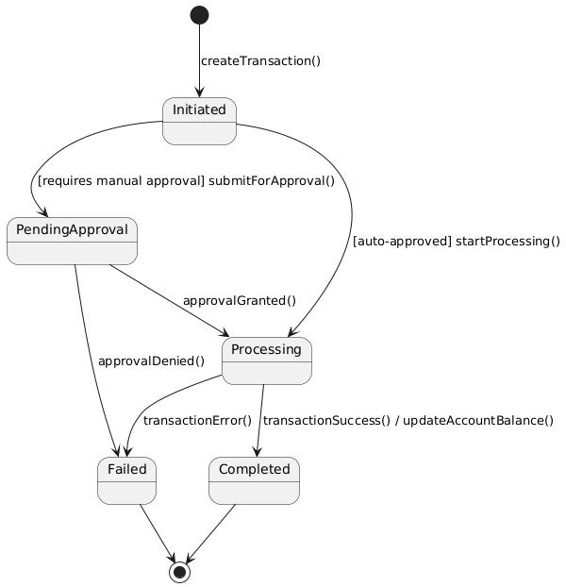

***Object 2: Notification – State Diagram***

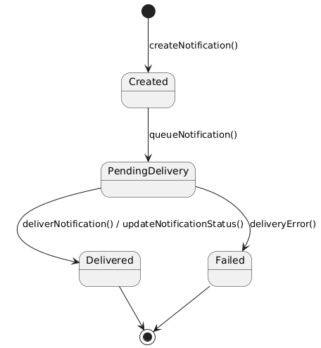

***\*\*SEQUENCE DIAGRAMS ABOUT 9-12 REQUIREMENTS\*\****

9. View All Client Accounts

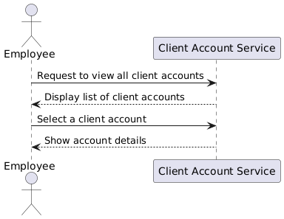

10. Update Client Account Information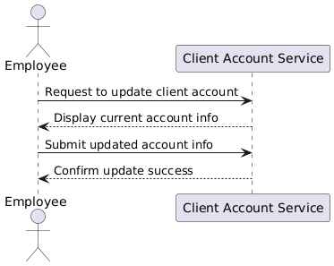

11. Check Client Loan Status

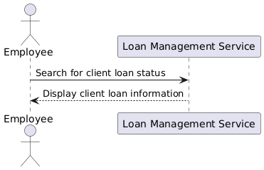

12. Manage Employee Accounts

